**IT Session 2 – Descriptive Analytics**

**Screenshot of Flight Data Dashboard**

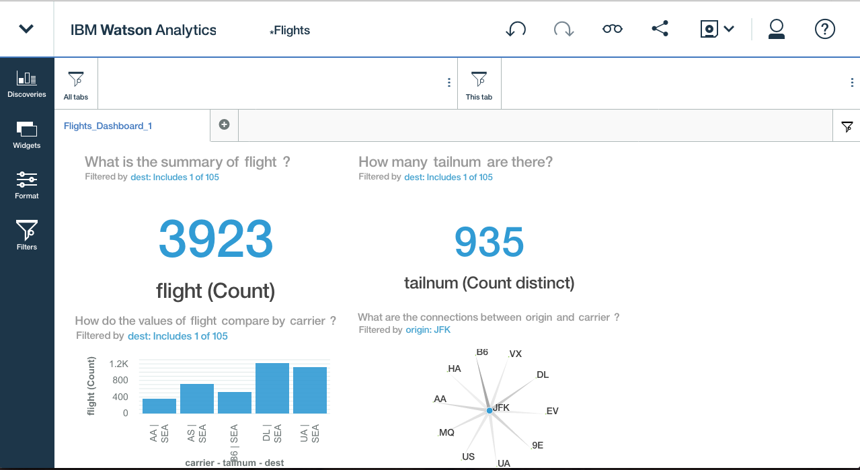

**Unique Airplanes Flying from NYC to Seattle**

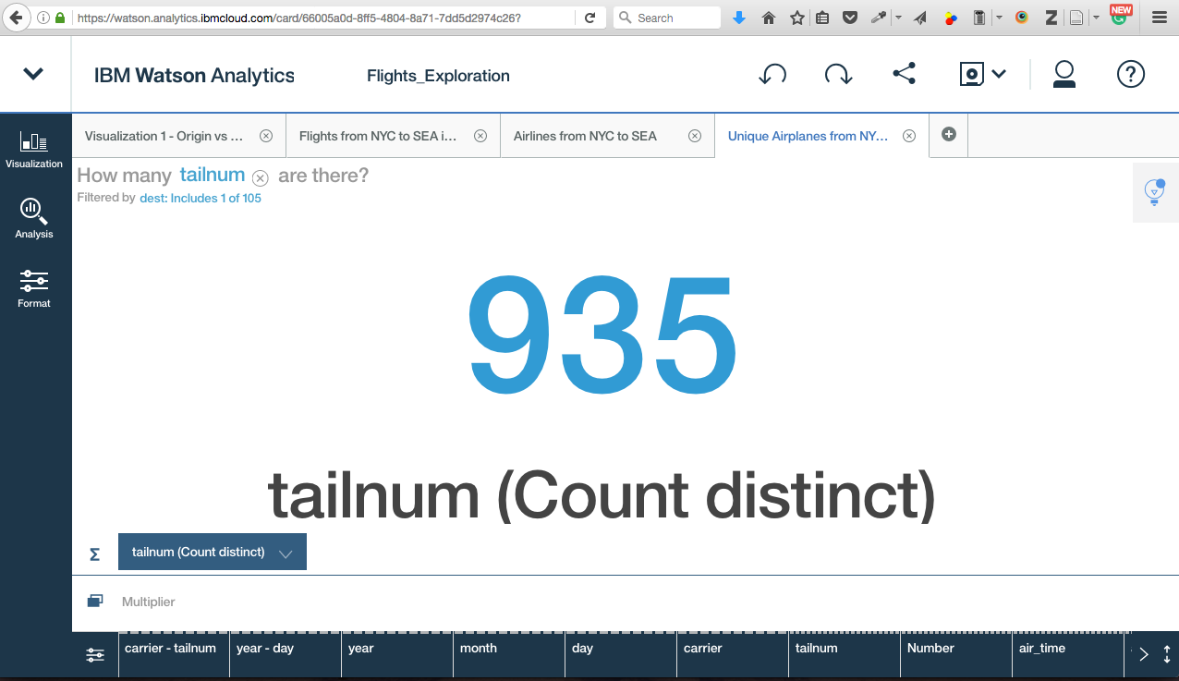

**Which airlines fly from NYC to Seattle and how many flights for each?**

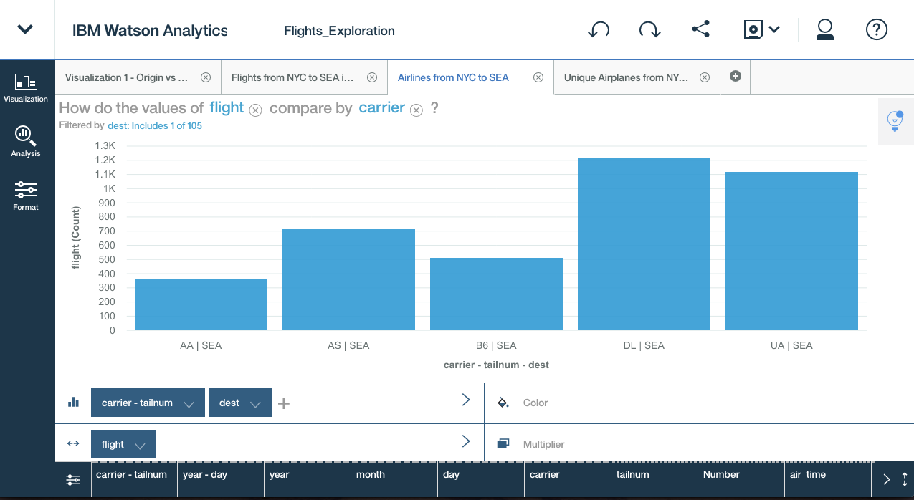

**Flights from NYC to Seattle in 2013**

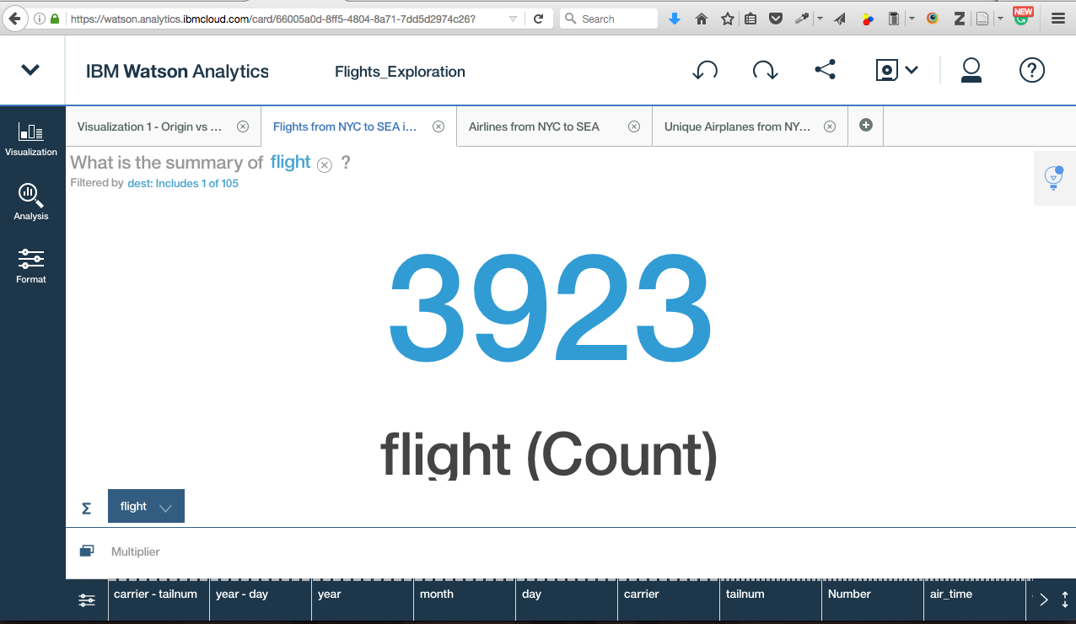

**Visualization for Connections between Origin and Carrier**

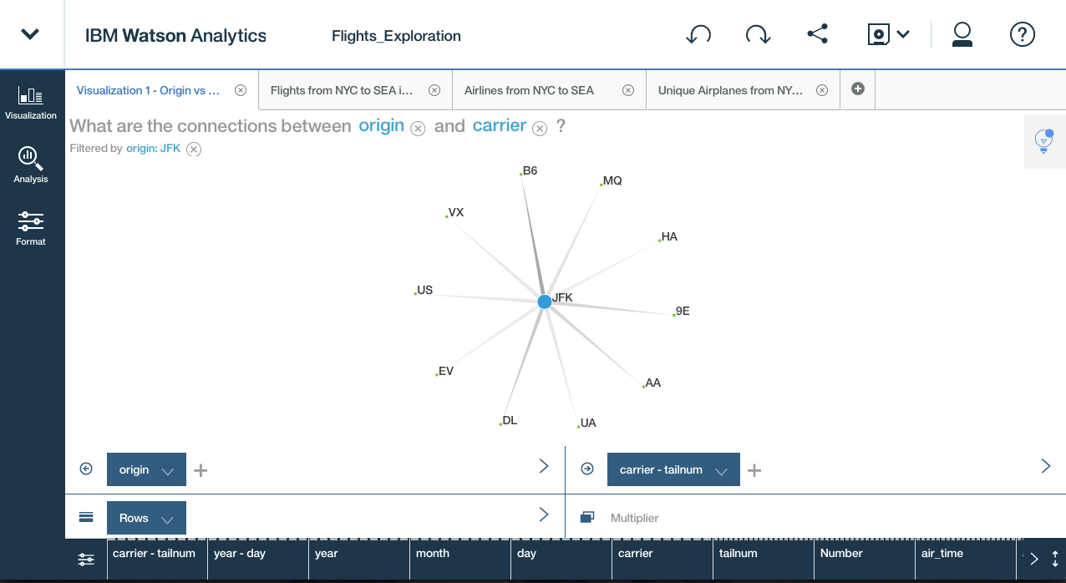

Shipra Gupta